**Name: Rahul Kumar** **Class: FYMCA (Div: B)**  **Roll No: 2201110**

**Q. Write a program to create function Add(), Mul(), Sub() and Div() to accept a variable length of arguments and print the respective results.**

def add(num1, *many):

sum = num1

for nos in many:

sum += nos

print("Sum = ",sum)

def sub(num1, *many):

dif = num1

for nos in many:

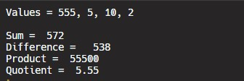 dif -= nos

print("Difference = ",dif)

def mul(num1, *many):

pdt = num1

for nos in many:

pdt *= nos

print("Product = ",pdt) **output**

def div(num1, *many):

quotient = num1

for nos in many:

quotient /= nos

print("Quotient = ",quotient)

print("Values = 555, 5, 10, 2 \n")

add(555, 5, 10, 2)

sub(555, 5, 10, 2)

mul(555, 5, 10, 2)

div(555, 5, 10, 2)